Door Head full Color Card
Software Operation Manual

I. Screen Debugging

- Click “ Settings ”--- “ Display Settings ”.
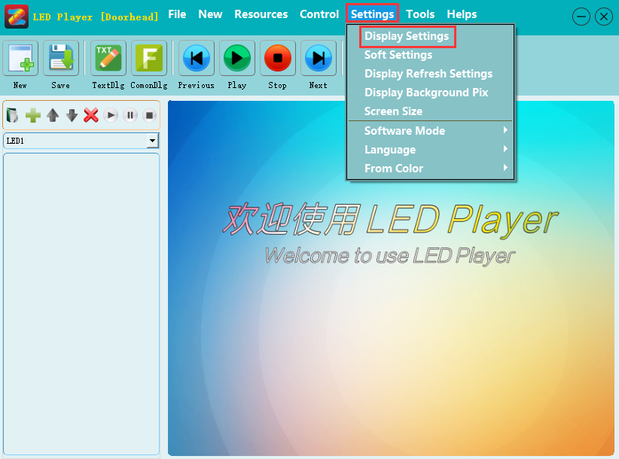

- After the information of device refreshed, click “ Screen Setting ”, the password is 168.
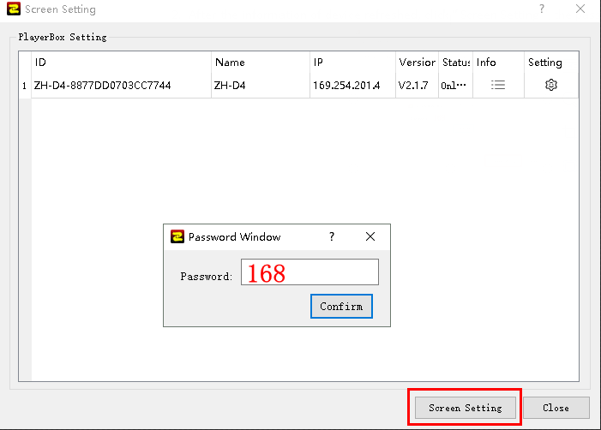

- Select the corresponding resolution (the resolution must be larger than the actual points on the display screen), click “ Set ”. At this time, the LED display screen will show the content: the resolution does not match with the display screen size. This is not setting error but is testing for each card before leave the factory. When encounter like the inconsistency between the reserved parameters and the actual parameters, just continue the next operation, no need to pay attention.
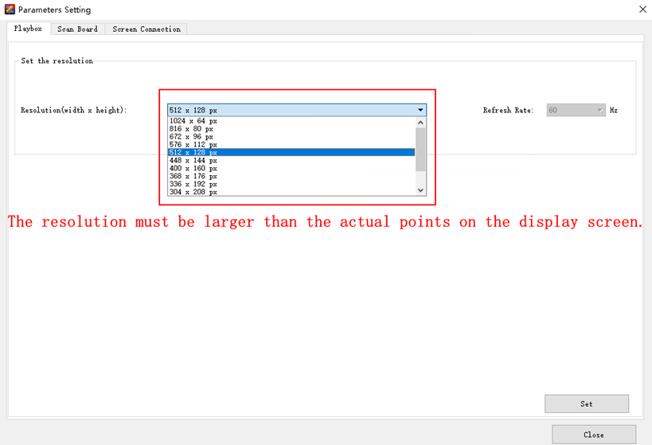

- Click “ Scan Board ” --- “ Select Module ”, to select the corresponding unit board model.
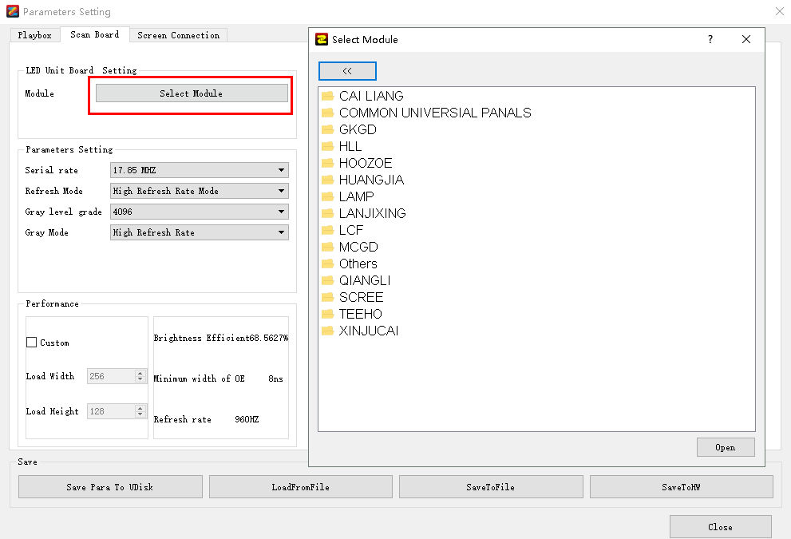

- Click “ Screen Connection ”, to configure the corresponding receiving card link order and click “ Send to Hardware ”.
( Note: The first card must be D4 on the screen connection interface, and then is the correct link order for receiving card. )
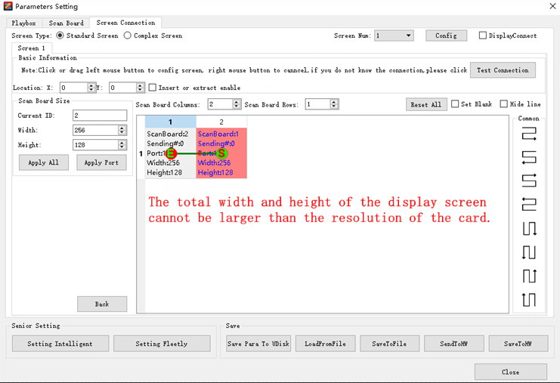

II. Edit Content
- Modify the size of the play window: Click “ Settings ”--- “ Screen Size”--- modify the “ Width ” and “ Height ”--- “Apply ”.
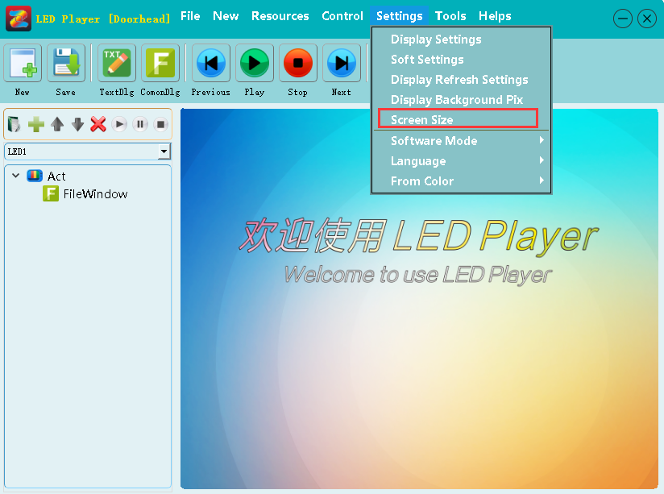

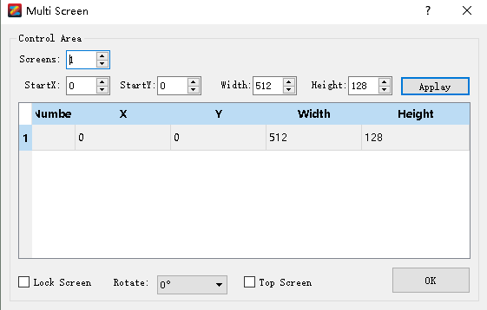
- Click “ New ” --- “ Multimedia Window ”, to add the corresponding material.
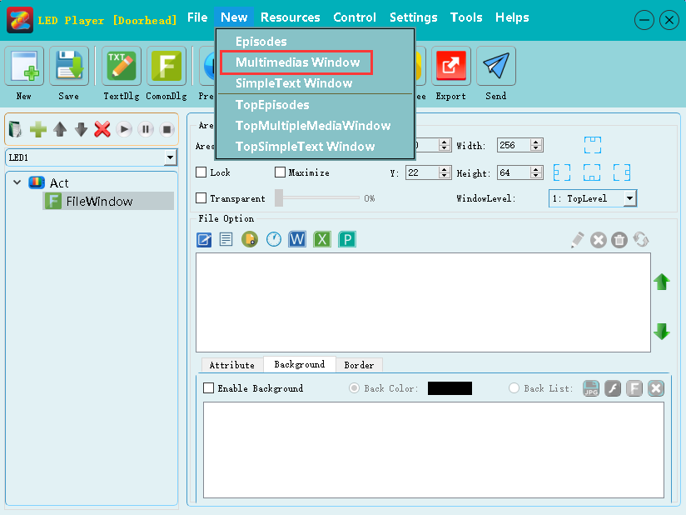

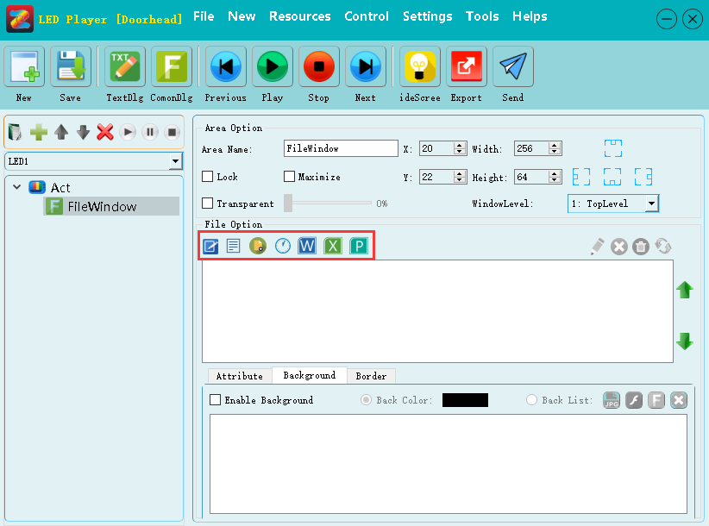
III. Upload Content
1. Upload content by U-disk.
1.1. Export through U-disk, click “ Export ” on the upper right corner of the software.
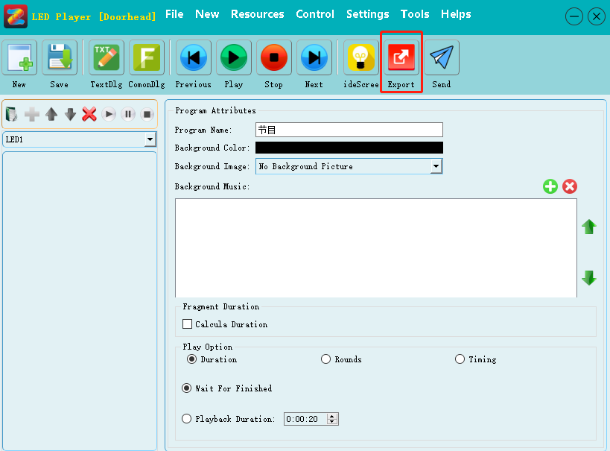

1.2. Click “ OK” in the pop-up window, when the window prompting “ The project data conversion is completed ”, means export successfully.

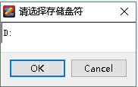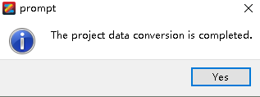

1.3. After click “ Yes ” can pull out the U-disk, then insert U-disk into USB port of the LED controller card.

2. Send content by Network cable line.
( Make sure the Windows Firewall be shut down when sending content by Network, otherwise it may cause sending fail. )
  - Click “ Send ” in the upper right corner.
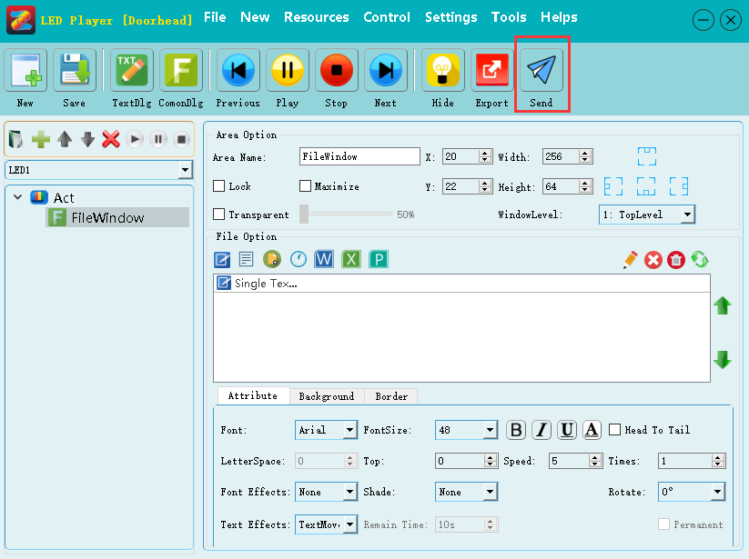

  - After the trans-coding is completed, will pop up sending interface, choose the corresponding device, and click “ Send ” is ok.
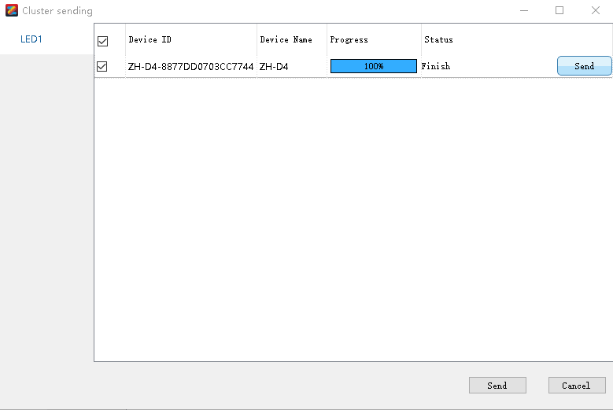

IV. Solutions For Common Problems:
Q: When uploading content, the display screen will show that the resolution does not match with the display screen size, why?
A: 1. The size of display screen does not match with the actual points of display screen. ( Click “ Settings ” --- “Screen Size ” --- “modify “ Width ” and “ height ”, to match with the actual points of the display screen --- “ Apply ”. )
2. Not maximized the size of the File Window.
Q: Sending by Network, the software always indicate the program have been send or have been send successfully, but there is no response on the display screen.
A: Enter into the control panel of the computer, close firewall of the Windows is ok.

